Zenith is the holder of Australian Financial Services License No. 226872 for the purposes of providing
“General Advice” (as defined by section 766B of Corporations Act 2001). General Advice provided by Zenith
is limited to Wholesale clients only.
This advice has been prepared without taking into account the objectives, financial situation or needs of any specific person who may read it. It is not a specific recommendation to purchase, sell or hold any relevant product(s).
Zenith advises that investors should seek their own independent financial advice before making any investment decision and should consider the appropriateness of this advice in light of their own objectives, financial situation or needs. Investors should obtain a copy of, and consider, any relevant product PDS or offer document before making any decision. This advice is prepared exclusively for clients of Zenith.
The material contained in this advice is subject to copyright and may not be reproduced without the consent of the copyright owner. The information contained in this advice is believed to be reliable, but its completeness and accuracy is not guaranteed. Zenith accepts no liability, whether direct or indirect arising from the use of information contained in this advice.

Manager Blending – What Is It?

Why blend managers/investment styles?

Approaches to Manager Blending

Manager Blending Tools & Analysis

- Combining fund managers of differing investment styles in a portfolio with a view to constructing a portfolio that will provide more consistent returns and capital protection through differing economic and investment market cycles.
- Essentially attempting to build a portfolio on the efficient frontier which maximises return for the level of risk
(volatility).

- Diversify investment style

  - Portfolios should not be over exposed/dominated by specific style as they perform differently and if the portfolio is totally or overly exposed to one style that underperforms for a period, so too will the portfolio (e.g. value underperforming growth for the decade after the GFC)
  - Different manager investment styles will perform differently based on differing market conditions

- Diversify manager business risk within portfolio

  - Reduce manager organisational and key person risk

Why Blend Manager Investment Styles?

- Aim to use lowly correlated managers

  - Build a portfolio of managers whose returns are not highly correlated with each other such that when some funds are underperforming others are performing strongly and propping up the returns of the portfolio
- Avoid ‘Deworsification’ – combining too many funds/managers can result in creating an expensive index
portfolio

Value vs Growth During GFC Drawdown Value vs Growth During GFC Recovery

10%

20%

30%

40%

50%

60%

MSCI Aus Value (Local) MSCI Aus Growth (Local)

180%
160%
140%
120%
100%
80%
60%
40%
20%
0%
-20%

MSCI Aus Value (Local) MSCI Aus Growth (Local)

Nov-07 Jan-08 Mar-08 May-08 Jul-08 Sep-08 Nov-08 Jan-09 Mar-09 Mar-09 Sep-09 Mar-10 Sep-10 Mar-11 Sep-11 Mar-12 Sep-12 Mar-13 Sep-13

10%

20%

30%

40%

50%

60%
Value vs Growth During COVID-19 Drawdown
MSCI Aus Value (Local) MSCI Aus Growth (Local)

45%
40%
35%
30%
25%
20%
15%
10%
5%
0%
Value vs Growth During COVID-19 Recovery
MSCI Aus Value (Local) MSCI Aus Growth (Local)

20-Feb 25-Feb 01-Mar 06-Mar 11-Mar 16-Mar 21-Mar
Source: Bloomberg
- Mar 02-Apr 12-Apr 22-Apr 02-May 12-May 22-May 01-Jun 11-Jun

  - Investment Philosophy – are you a believer of active or passive? If active, in all asset classes or only less efficient markets?
- Objective of the portfolio (focus on capital growth or capital protection or a hybrid of the two)

- Required Return Characteristics (Capital Appreciation or Income)

o For example a high portfolio turnover investment style will generally lead to a greater proportion of income in total return than a low turnover manager
  - Size of portfolio / investable amount will influence the number of investments used and ability to diversify investment styles
    - Avoid ‘Deworsification’ – large FUM for some institutions has resulted in combining too many funds/managers which can result in creating an expensive index portfolio

- Factor Analysis

- Ratios & Statistics

- Portfolio Holdings

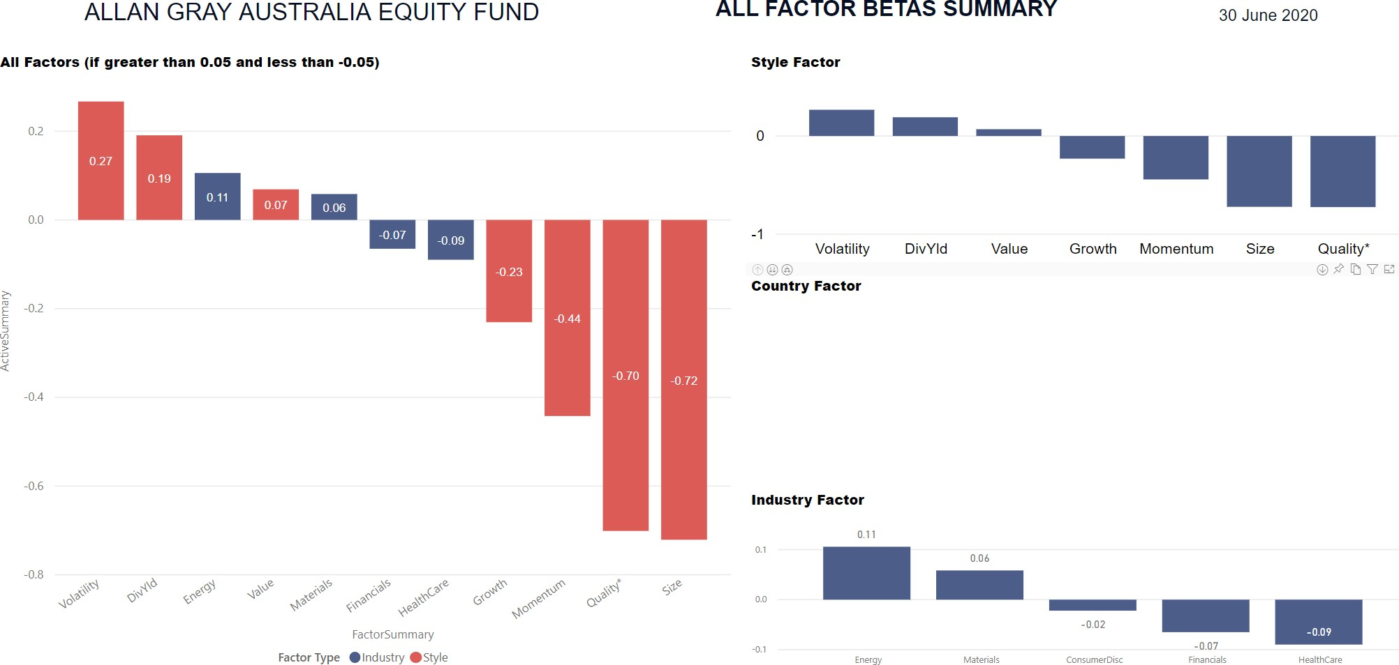

DELTA
Research and Advisory

Delta Factors
Understand ing Invest ment Performance Beha viour Australian Eq uit ies Benchmarks
Rolling 36 months
M: PO !lox ·15820 C1ly Easl OLD 4002
P: +61432002 472
E: in fo@d elta,esearch com.au
W: www.delleresearth com.au
ABN ;4 3 155 969 163 AFSL: 420093

Benchmark
M SCI Au st ral ia IMI
Sector
Al l
APIR Code Al l
Fund
Allan Gra y Au stralia E quity TR i n AU
Exposures (Betas), Value -add (Alphas) and Volat ilit y of Allan Gray Aust ra lia Equity TR in AU

Factor

Port fo lio Risk Cont ribut ion of Allan Gray Austra li,a Equity TR in AU
Ris1<. Free Excess. 0.2 0.160
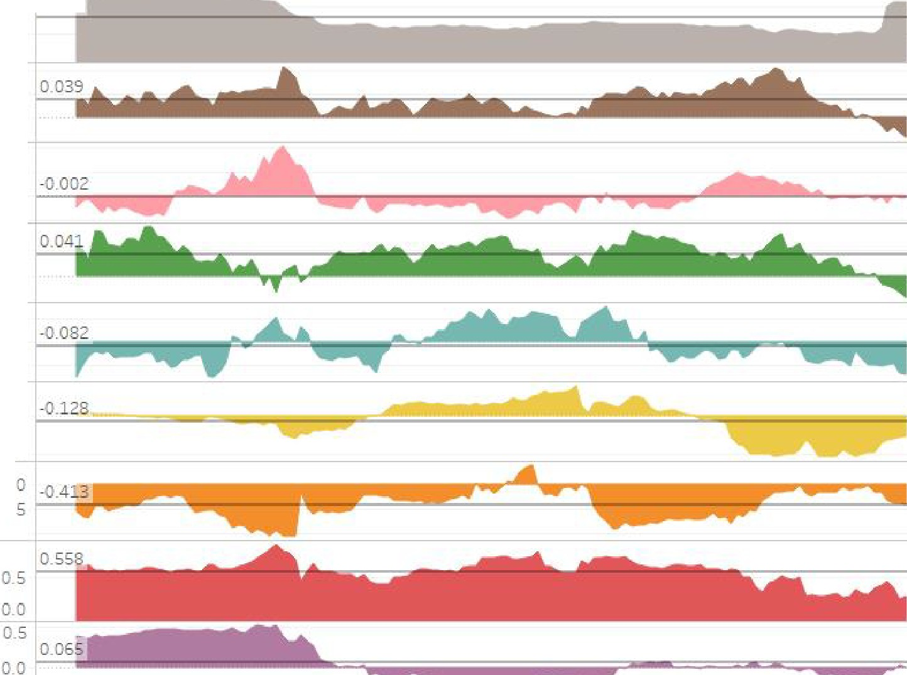Return Vol ati li t y 0.1

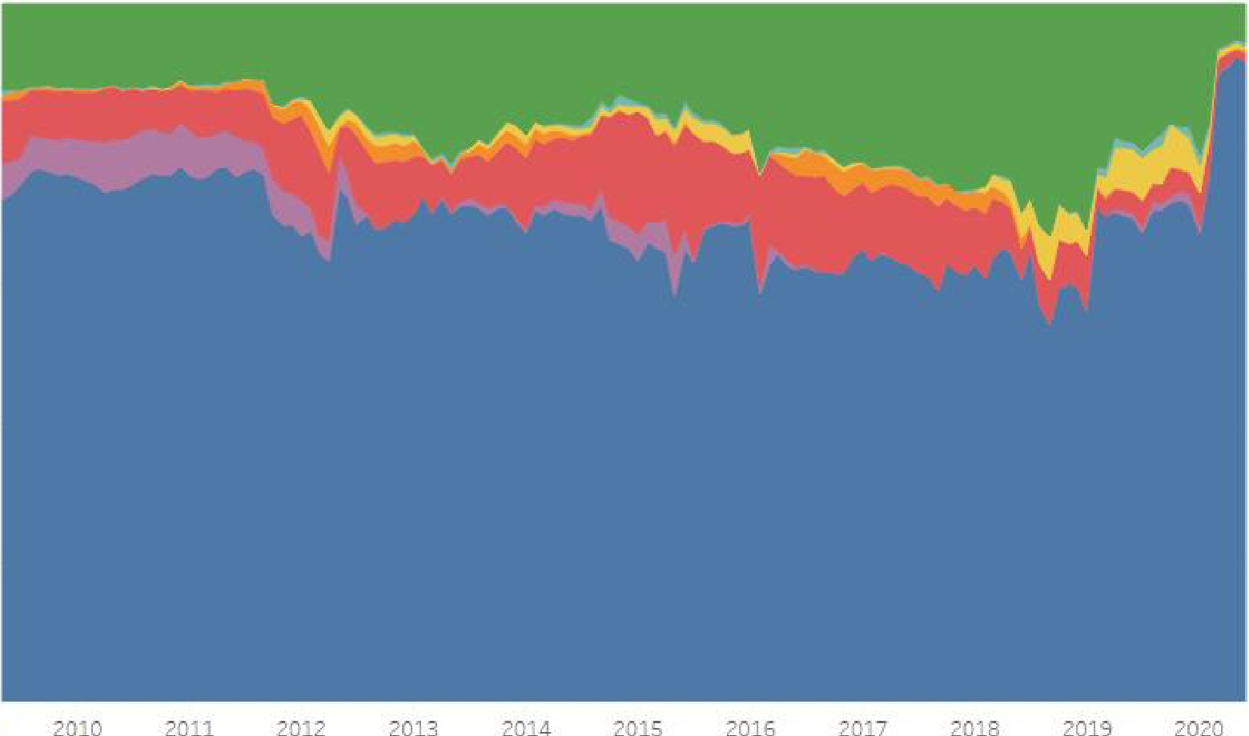
1.0
CAPM (Mark et )
0.1
0.039

Alpha o_o

0.3

QJ 0_6
:,
-.;
..
>
°:, '
6F Sty le Abha 0.05
-0.0 5

().() 5
6F Alph a 1}_00

Mir Vol at il it y 0

0.4

Qua li t y
0 .1 28
-1
o_

0-2
M om em: um -0_5

o_o

20()9

Month of Date
Small minus Big
(SMB)

Valu e minu s Grm-.ith
(VMG}

Facto r
■
6F ldio, yncr at ic Risk Cont r i l>ut ion Min V olat il it y Rjsk Contr ibut i on Qua lity Ri s Cont r rbuti on
■
■
M o ent u Risk Co ri ut io n
- SMB Risk Cont r ibut io n
- VMG Ri sk Cont r ibu t io n
- Mark et Ri sk Con t r tbut ion

CAPM (Mark et ) Beta

2009 2010 2011 2012 2013 2014 2015
Mont h of Date

2016 2017 2018 2019 2020

Date
31/ 07/ 2007 to 30/ 06/ 2020

10
Zenith
l n 11e s1 m e n t Partners

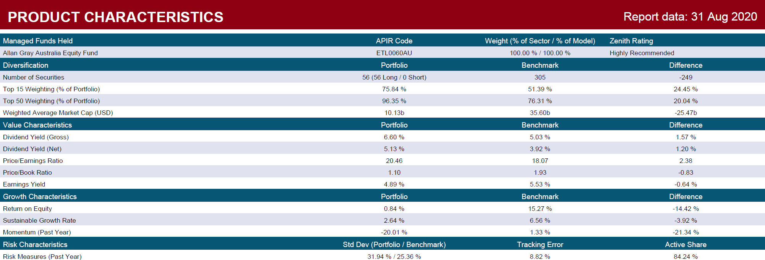

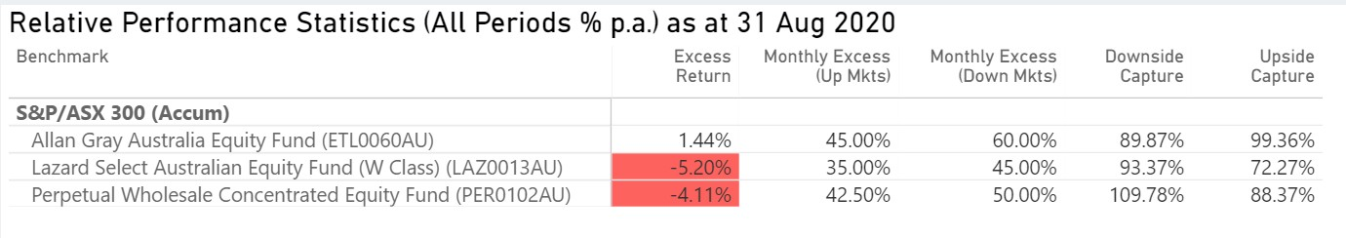
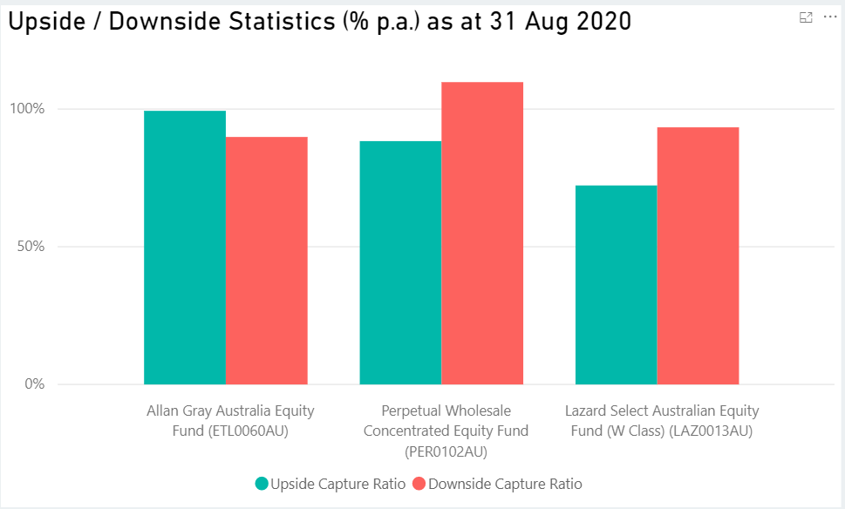

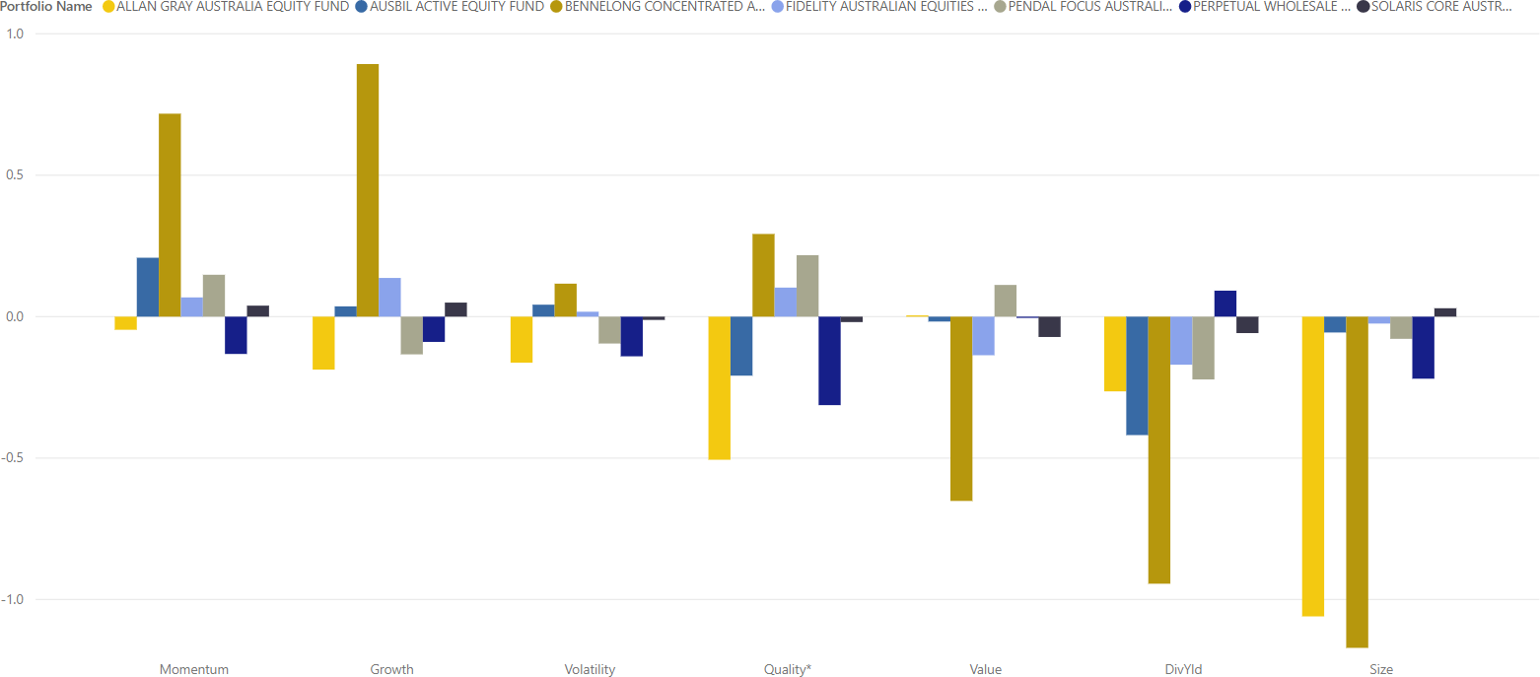

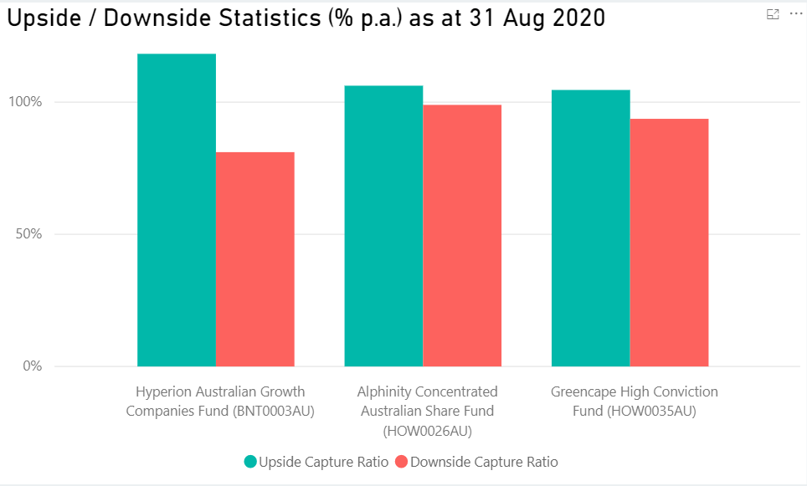

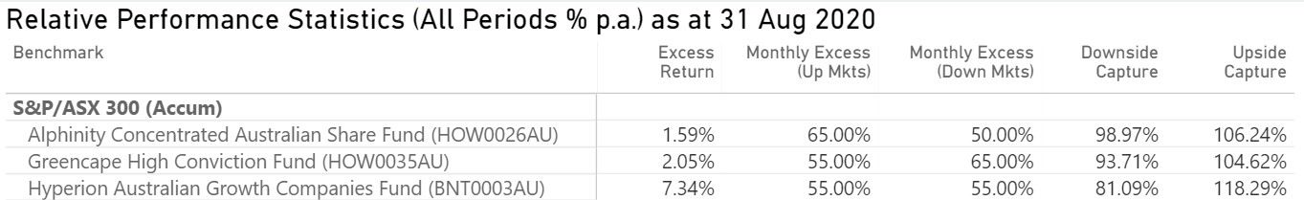

14

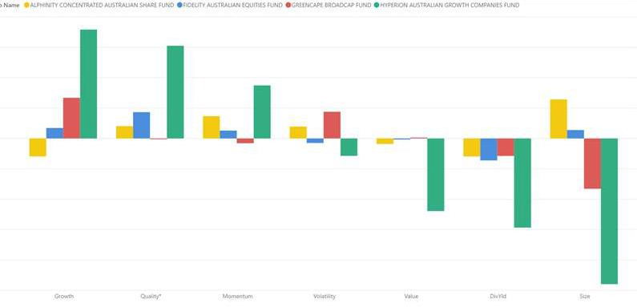

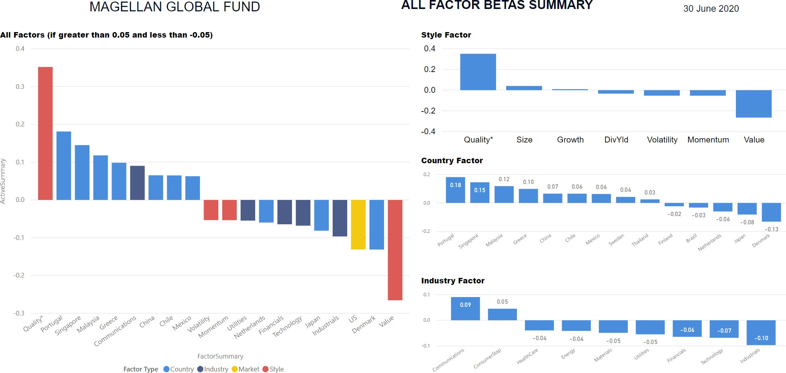

DELTA
R=rch and Advlso

Delta Factors
Underst and ing Investment Per formance Behav iour Globa l Equit ies Benchmarks
Rolling 36 months
M: PO Box 151!20 City Easl QLD 4002
P: +51 432 002 472
E: info@delt11rvsearch.com.au
W: www.<'.le[tareseerCl,l.Gom . eu
ABN: 43155009 16 3 AFSL: 420093

Benchm ark M SCI W orl d
Sect or
All
APIR Co d e
All
Fun d
M agellan Gl obal R i n AU
Exposu res (Bet as ), Value-ad d (Alpnas) and Volat ili ty of M agellan Global TR in AU
Fa cto r

Por tfo lio R isk Cont ribut ion of Mage ll an Globa'I TR in AU

1.0

0.9

0.8

0.7

., 0.6
::,
-;;;
::,,
ci, 0.5
>
"'

R is k Free Excess Re t u rn Vol at il ity

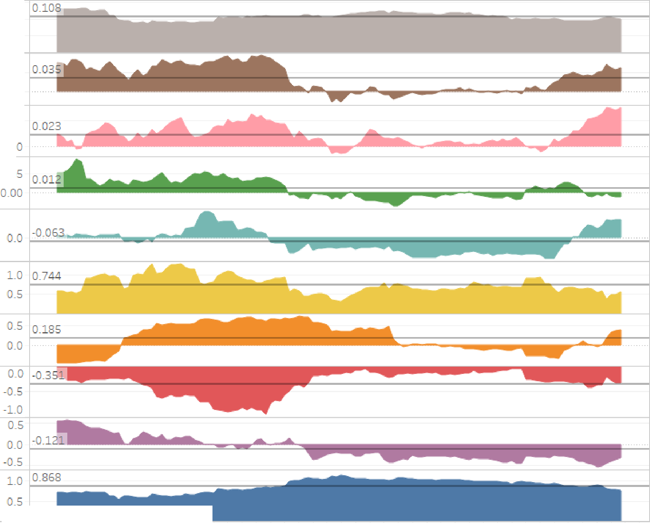CAPM (Ma rket ) Alpha
0.10
0.05
0.05
0.00
0.0

6F Style Alpha

6F Al ph a

Min Vo lat il it y
0.  LO  O.S  O.S | 0.744
0.0
0.0
-0.5
-L O
0.5
0.0
-0.5
LO
0.5

0.4

0.3

0.2

Qua l it y

Momentum

0.1

0.0

Fact or

2010 2011 2012 2013 2014 2015 2016
Mont h of Date

2017 2018 2019 2020
Small mi nus Big
(5M B)

Va l u e minus
Gro w t h (VMG)

CAPM (Ma rket )

- 6i' Idi osy ncr at ic Risk Cont r i b u t i on
- M in Volat i li t y i sk Con t r i but i o n
Qu ality Risk Con t r ib u t ion
■
M ornent um Ri s k Co nt r ib u t i o n
- SM B Risk Con t r ibut ion
- VMG Ri sk Co n t r ib u t i on
- M ar ket R is k Co n1 r ibu t i o n

Be ta

2010 2011 2012 2013 2014 2015 2016
Mont h o f Da t e

2017 2018 2019 2020

Date
31/0 7/ 20 7 to 3 {06/ 2020

Zenith 17
l n 11 e s1 me n t P a r tn er s

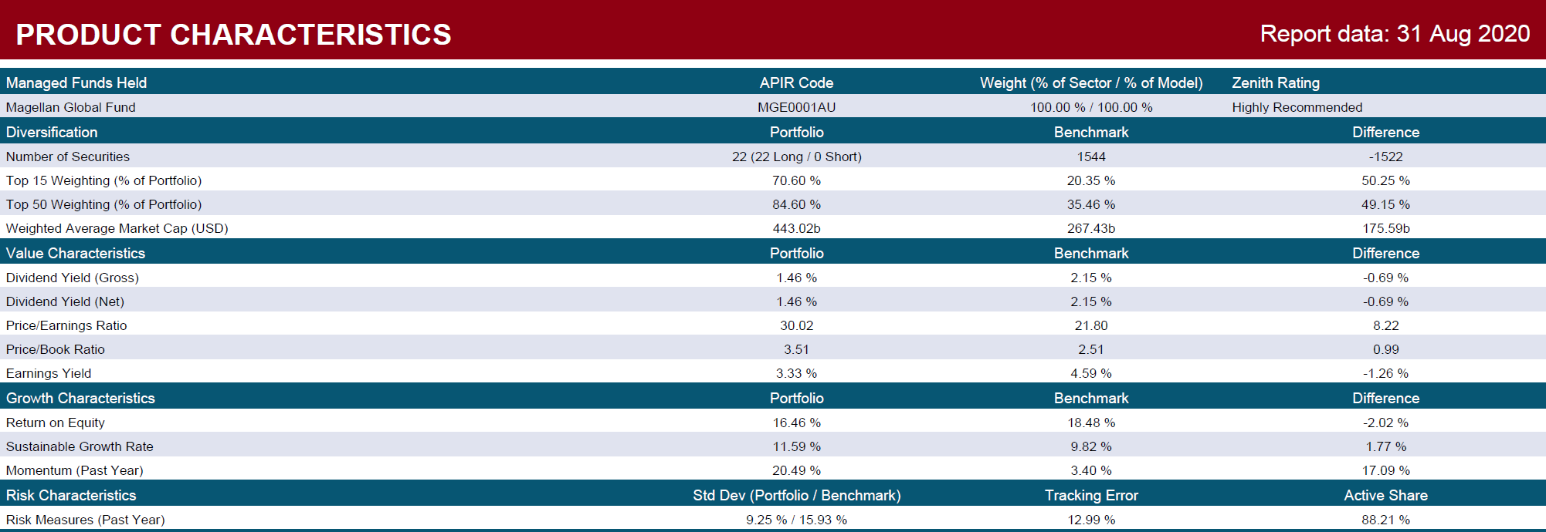

Name | Asset Class | Defensive | Moderate | Balanced | Growth | High Growth
CASH
Cash Account | Cash | 20.00% | 15.00%
 | Sector Total | 20.00% | 15.00% | 0.00% | 0.00% | 0.00%
DIVERSIFED FIXED INCOME | ]
Fund 1 | Global Bonds | 15.00% | 10.00% | 10.00% | 10.00%
Fund 2 | Australian Fixed Interest | 10.00% | 10.00% | 10.00%
Fund 3 | Diversified Fixed Interest | 15.00% | 10.00% | 10.00% | 10.00%
Fund 4 | Diversified Fixed Interest | 10.00% | 10.00% | 10.00%
Fund 5 | Diversified Corporate Debt | 10.00% | 5.00%
 | Sector Total | 60.00% | 45.00% | 40.00% | 20.00% | 0.00%
AUSTRALIAN SHARES
Fund 1 | Australian Shares - Large Companies - Growth | 4.50% | 3.00% | 4.50% | 6.00% | 7.50%
Fund 2 | Australian Shares - Large Companies - Value |  | 3.00% | 4.50% | 6.00% | 7.50%
Fund 3 | Australian Shares - Active Extension (130-30) |  | 3.00% | 4.50% | 6.00% | 7.50%
Fund 4 | Australian Shares - Mid Cap Companies - Growth | 2.50% | 3.00% | 4.50% | 6.00% | 7.50%
Fund 5 | Australian Shares - Small Companies - Value |  | 3.00% | 4.50% | 6.00% | 7.50%
 | Sector Total | 7.00% | 15.00% | 22.50% | 30.00% | 37.50%
INTERNATIONAL SHARES
Fund 1 | Global Unhedged - Value |  | 5.00% | 7.50% | 5.00% | 6.75%
Fund 2 | Global Unhedged - Growth |  |  |  | 5.00% | 6.00%
Fund 3 | Global - Variable Long Short | 7.00% | 5.00% | 3.75% | 5.00% | 6.00%
Fund 4 | Global Hedged - Neutral |  | 3.00% | 4.25% | 6.00% | 7.75%
Fund 5 | Emerging Markets - Unhedged |  |  | 2.00% | 2.50% | 3.00%
Fund 6 | Global Resources - Unhedged |  |  | 2.00% | 2.50% | 3.00%
Fund 7 | Global Listed Infrastructure - Hedged |  | 2.00% | 3.00% | 4.00% | 5.00%
 | Sector Total | 7.00% | 15.00% | 22.50% | 30.00% | 37.50%
REITs
Fund 1 | AREITs | 3.00% | 2.00% | 3.00% | 4.00% | 5.00%
Fund 2 | GREITs - Hedged |  | 2.00% | 3.00% | 4.00% | 5.00%
 | Sector Total | 3.00% | 4.00% | 6.00% | 8.00% | 10.00%
ALTERNATIVES
Fund 1 | Market Neutral |  | 2.00% | 3.00% | 4.00% | 5.00%
Fund 2 | Macro |  | 2.00% | 3.00% | 4.00% | 5.00%
Fund 3 | CTA | 3.00% | 2.00% | 3.00% | 4.00% | 5.00%
 | Sector Total | 3.00% | 6.00% | 9.00% | 12.00% | 15.00%
Defensive |  | 80.00% | 60.00% | 40.00% | 20.00% | 0.00%
Growth |  | 20.00% | 40.00% | 60.00% | 80.00% | 100.00%
TOTAL |  | 100.00% | 100.00% | 100.00% | 100.00% | 100.00%

  - Blending of Manager Investment Styles is a critical component of portfolio construction

  - Different investment styles perform differently and in different investment market and economic conditions

  - Style diversity is an essential risk management tool in portfolio construction

Delta Research Factor Background

Delta Research Factor Definitions

Portfolio Holdings

  - A combination of:
    - Performance Based Style Analysis – William Sharpe
    - Arbitrage Pricing Theory – Stephen Ross

2 of 3 total Wharton Jacobs-Levy Prizewinners for Quantitative Financial Innovation

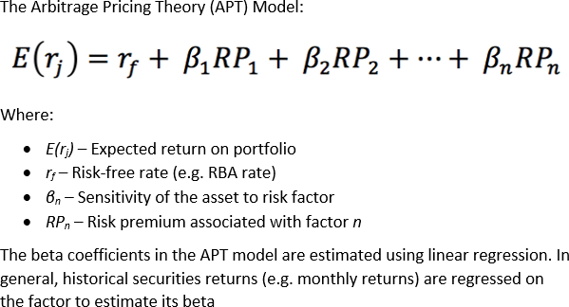

- Market – MSCI World, MSCI ACWI, MSCI Australia, MSCI Australia IMI
- Value minus Growth (VMG) – This is the value factor and the beta is positive if value style, or negative if growth style.
  - Value securities have low Price/Book, Fwd PE, or high Dividend Yield;
  - Growth securities have high EPS Growth, Revenue growth, and/or Internal growth
- Small minus Big (SMB) – This is the Size factor and the beta is positive if the portfolio is biased towards
smaller securities and negative for large-cap securities.
  - Size is based on market capitalisation
- Momentum – Positive Momentum beta occurs if a portfolio is biased towards holding best performing securities over previous 6/12 months
- Quality – Quality securities generally have low levels of debt; positive and consistent profit
- Minimum Volatility – Minimum Volatility securities generally have low levels of volatility or low market beta

