Portfolio Risk Management Strategies

Learning Objectives
- Describe the multifactor approach to portfolio risk management.
- Identify various sources of risk that may be identified and managed within a portfolio.
- Describe how risk may be managed using futures and options.
- Value-at-Risk as a measure of portfolio downside risk.
- Risk budgeting and Value-at-Risk
- Explain how risk may be decomposed using value-at-risk to measure a portfolio’s overall risk.

Investment Management Analyst Certificate (IMAC) | Portfolio Risk Management Strategies 1

Portfolio Risk Management

- Asset allocation and risk management: are about finding the right balance between risk and return.

- Look at tools to measure, monitor, and manage the risk of a portfolio.

- Asset allocation is the same as risk allocation : meeting investor’s investment goals comes from

actively monitoring and managing the risk of the portfolio.

- While managing a portfolio to earn a high rate of return is difficult, managing the risk profile of a portfolio is relatively easy.

Investment Management Analyst Certificate (IMAC) | Portfolio Risk Management Strategies 3

Risk Management: Multifactor Approach

  - The goal of risk management for portfolio management is to find the right combination of risks that is consistent with the investor’s risk preference and not to expose the portfolio to risks that do not contribute to its long-term performance.

  - The portfolio should be constructed to have exposures to those sources of risk that contribute to the portfolio’s performance, and the exposure should be relatively low for those sources of risk that do not provide a large benefit.

  - Managing the risk of multi-asset portfolios is a multistep process .

Investment Management Analyst Certificate (IMAC) | Portfolio Risk Management Strategies 5

Risk Management: Multifactor Approach
Step 1: Understanding the investor: attitudes toward risk, liabilities, why hold the portfolio.

Step 2: Understanding the portfolio: what are the sources of risk.
    - the long run, the major determinants of a portfolio’s total return are its exposures to various sources of risk.

Step 3: Measuring the exposure of a portfolio.
    - The most common approach is to use a multivariate linear regression to measure exposure.
    - Multifactor models can be very effective as long as one can find a factor that has pure exposure to the desired source of risk.

Step 4: Determining the potential reward from various sources of risk.
    - Need to estimate risk premiums associated with various factors.

Step 5: The final step is to construct the portfolio with the appropriate risk attributes and then monitor changes in those risk exposures through time to ensure that the portfolio remains within the parameters set in the investment policy statement.
Investment Management Analyst Certificate (IMAC) | Portfolio Risk Management Strategies 8

Sources of Risk
Financial Risks
Market Risk
Credit Risk
Other Risk
Interest Rate Risk
Equity Risk

Currency Risk

Commodity Risk
Volatility Risk

Operational Risk

Inflation Risk

Investment Management Analyst Certificate (IMAC) | Portfolio Risk Management Strategies 9
Liquidity Risk

Market Risk

- Market risk is the risk of loss from adverse movements in the mark-to-market value of a portfolio
during the period required to liquidate the transactions.

- Market risk generally arises from movements in the underlying risk factors that affect the value of positions in the portfolio. These risk factors include
  - interest rates,
  - exchange rates,
  - equity prices,
  - commodity prices

- A portfolio’s market risk exposure is determined both by the volatility of underlying risk factors and the sensitivity of the portfolio to movements in those risk factors.

Investment Management Analyst Certificate (IMAC) | Portfolio Risk Management Strategies 12

Market Risk

- Equity risk: arises from unexpected changes in global equity prices.
- Since equity prices are expected have a positive return in the long run, higher exposure to this risk should lead to higher return.

- Interest rate risk: affects fixed income instruments and equity prices of financial institutions.

- Currency risk: affects positions denominated in foreign currencies .
- if the hedging cost is zero, one may consider eliminating this risk as it does not contribute to portfolio returns.

- Commodity risk: Commodities have become an increasingly important asset class in recent years.
- A portfolio may have exposure to unexpected changes in commodity prices even if it does not have direct investment in commodities; for example, an unexpected increase in oil price may significantly affect several sectors of the economy.

Investment Management Analyst Certificate (IMAC) | Portfolio Risk Management Strategies 14

Market Risk

- Inflation risk: occurs due to changes in interest rates and commodity prices.
- This is a larger risk for those portfolios where the total return is supposed to fund operations of an entity, cover the cost of living of a family, or pay for the replacement of real assets.

- Others: Risks associated with various economic sectors, small capitalization firms, emerging markets, and so on.

Investment Management Analyst Certificate (IMAC) | Portfolio Risk Management Strategies 15

Credit Risk

- Credit and counterparty risk: This risk is caused by the failure of a counterparty or a debtor to
meet its legal obligations.

- May also be caused by changes in the credit rating of a counterparty.

- Counterparty risks arise whenever positions are established in over-the-counter instruments
such as credit derivatives, interest swaps, or forward contracts.

- Higher exposure to credit risk may not always lead to higher return on the portfolio. This is
especially correct for counterparty risk, where higher return may come at too high a cost.

- Most instruments that are exposed to counterparty risk are purchased for risk management purposes rather than return enhancement. The cost of not having the anticipated protection when it is needed could be quite high.

Investment Management Analyst Certificate (IMAC) | Portfolio Risk Management Strategies 17

Other Types of Risks

Liquidity risk: arises when an investment cannot be converted into cash quickly without
paying a significant penalty.

- For exchange-traded instruments, this risk can be measured using the bid-ask spread.

- Liquidity risk is not constant and could arise exactly when liquidity is most valued. (e.g.: GFC, restrictions
on redemptions imposed by hedge funds.

- Can be a major source of return for some alternative asset classes (e.g., private equity and some hedge fund strategies).

- Quantitative methods to measure liquidity risk are not well developed

- Use common sense and qualitative due diligence should be used.

Investment Management Analyst Certificate (IMAC) | Portfolio Risk Management Strategies 20

Other Types of Risks

- Operational risk: arises if the portfolio has allocation to active managers. System failures, lack of adequate control, and fraud are examples of operational risk that could affect a portfolio’s performance.
- There are generally no rewards for exposure to operational risk and therefore it pays to avoid it.

- Others: There are several other sources of risk that could affect a portfolio’s return.
- Political risk may be important for a portfolio that has allocation to emerging economies.
- Changes in regulatory environment and tax codes represent additional sources of risk.

Investment Management Analyst Certificate (IMAC) | Portfolio Risk Management Strategies 22

Portfolio Risks

In general, the higher the total risk of a portfolio, the higher its long-term rate of return
(assuming normal conditions).

- However, during periods of market stress, higher risk is typically associated with lower returns.
- Investors begin to reassess their risk exposures and sell risky assets during such periods. So higher risk is associated with lower return during periods of market stress.

- Further, even in the long-run not every risk exposure is going to translate into higher return.
- Example: Suppose that a portfolio manager is considering allocation to both AAA and BBB rated corporate bonds. Depending on the current risk profile of the portfolio and the investor’s attitude toward risk, one may decide to increase the allocation to BBB rated bond index in order to generate a higher return over time.

Investment Management Analyst Certificate (IMAC) | Portfolio Risk Management Strategies 24

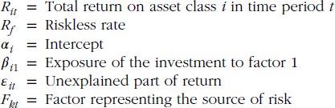Measuring a Portfolio’s Risk Exposure
- The most common approach to measure exposure is to use a multivariate linear regression.

- The general form of a multifactor is:
(1)

where

Investment Management Analyst Certificate (IMAC) | Portfolio Risk Management Strategies 26

Multifactor Models of Risk Exposure

- The factors must be selected carefully so that they unambiguously represent a unique source of
risk.

- For example, credit risk can be expressed as the difference between the return on a high-yield bond index and the return on a Treasury Bond index with the same duration.

- Interest rate risk can be measured as the return differential between an index of medium-term Treasuries and short-term Treasuries.

- Generally, one should attempt to represent the factors as excess returns on portfolios.

Investment Management Analyst Certificate (IMAC) | Portfolio Risk Management Strategies 28

Multifactor Models of Risk Exposure

- Some commonly used risk factors:
- Market portfolio
- Inflation
- Interest rates
- Credit spreads
- Change in industrial production
- Change in expected inflation
- Change in unanticipated inflation
- Excess return of long-term corporate bonds over long-term government bonds
- Excess return of long-term government bonds over T-bills

Investment Management Analyst Certificate (IMAC) | Portfolio Risk Management Strategies 30

Rewards from Risk Factors

Step 3 : Determining the potential reward from various sources of risk by estimating risk.

- For those risk factors that are represented by returns on traded assets, the risk premium can be estimated by examining the excess return on the corresponding asset.
Example: price of credit risk = Average(return on high-yield bond index – return on Treasury bond index)

- If no such asset can be identified, then create a portfolio with high exposure to the factor and a portfolio with low exposure to the same factor. The mean of the return differential between the two portfolios is a reasonable estimate of the risk premium associated with that factor.
  - Example: if the mean return for a portfolio with positive exposure to inflation is not different from the mean return on a portfolio with negative exposure to inflation, then inflation risk is not priced by markets.
  - This means that having exposure to inflation is not likely to contribute to the portfolio’s performance and therefore should be eliminated, assuming the cost of doing so is zero.
Investment Management Analyst Certificate (IMAC) | Portfolio Risk Management Strategies 32

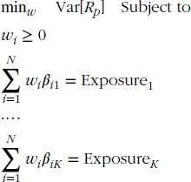The Multifactor Model

- Given the factor model in (1), the expected return on the portfolio is given by

- The expected total return on the portfolio is primarily determined by its exposure to various sources of risk.

The weights should be selected to manage the portfolio’s risk exposures:

This means the portfolio is constructed to have minimum volatility subject to various constraints on the portfolio’s exposure.

Investment Management Analyst Certificate (IMAC) | Portfolio Risk Management Strategies 33

The Multifactor Model

  - Typically, the above analysis is performed using available equity, fixed income, and alternative
asset indices.

  - Once the optimal allocations are determined, the portfolio manager has to find the investment products that have the same characteristics as those indices.

  - When considering alternative asset classes and especially those for which manager skill is rather important, it may be impossible to find managers who have the same exposures as the indices.

  - In some cases, the portfolio manager may need to revise the equity and fixed income exposures of
the portfolio in order to rebalance the overall exposure of the portfolio.

Investment Management Analyst Certificate (IMAC) | Portfolio Risk Management Strategies 36

Risk Management and Hedging

Investment Management Analyst Certificate (IMAC) | Portfolio Risk Management Strategies 38

Risk Management with Hedging
- Hedging removes risk. Hedging involves establishing a second position whose price behavior
will likely offset the price behavior of the original portfolio.

- The objective of portfolio protection is the temporary removal of some or all the market risk associated with a portfolio. Portfolio protection techniques are generally more economic in terms of commissions and managerial time than the sale and eventual replacement of portfolio components.

- Options and futures enable the portfolio manager to adjust the characteristics of a portfolio without disrupting it.

- Knowledge of options and futures improves the portfolio manager’s professional competence.

Investment Management Analyst Certificate (IMAC) | Portfolio Risk Management Strategies 40

Risk Management Using Options

  - Options can be used to implement drastic changes in the risk-return profile of an investment.

  - Traditional long only assets offer investors a limited set of choices in terms of directly managing the risk of the underlying spot positions.

  - Futures contracts help to reduce or increase the underlying variability of an asset, but futures do not permit one to fundamentally change the risk structure of the asset (e.g., create a skewed distribution).

  - Options (when available) provide the means to purchase (call) or sell (put) a security in the future for a price determined today. Unlike with a futures contract, the holder of an option has the right but not the obligation to make or accept delivery.

  - Two examples involving using options to manage the risk profile of an investment.

Investment Management Analyst Certificate (IMAC) | Portfolio Risk Management Strategies 42

Protective Puts

- A protective put is a long stock position combined with a long put option.

- Protective puts are useful for investors who:
- Hold a position in an asset and does not want to liquidate the position.
- Expect a decline in the value of the asset.

Assume option premiums for CBA (current price = $60)

Strike | Calls |  |  |  | Puts
 | Sep | Dec | Mar |  | Sep | Dec | Mar
50 | 12.00 | 12.80 | 13.98 |  | 0.90 | 1.60 | 2.10
55 | 5.90 | 6.73 | 7.47 |  | 1.50 | 2.97 | 3.78
60 | 2.30 | 3.90 | 4.83 |  | 3.40 | 4.70 | 6.12
65 | 0.90 | 1.40 | 2.50 |  | 6.20 | 7.89 | 8.99

Investment Management Analyst Certificate (IMAC) | Portfolio Risk Management Strategies 44

Protective Put : Profit & Loss Diagram
- Long position for CBA stock:
Profit or Loss

0

-60

$60

Stock Price at Option Expiration

Investment Management Analyst Certificate (IMAC) | Portfolio Risk Management Strategies 45

Protective Put : Profit & Loss Diagram

- Protective put diagram:
Profit or Loss

Maximum
Gain is unlimited

0

-6.5
Stock Price at Option Expiration

Maximum Loss = $6.5
$55

Investment Management Analyst Certificate (IMAC) | Portfolio Risk Management Strategies 47

Risk Management Using Options: Covered Call

  - Covered Call : A covered call writing strategy (or a buy-write) entails the writing (selling) of a call on an equity index against a long position in the same underlying equity index.
- may also be implemented on individual equities or other indices that have options written on them.

  - The sale of the call sacrifices a portion of the upside return distribution of the underlying
index in exchange for the collection of a fixed premium.

  - The extent of upside participation depends on the initial moneyness of the written call.
- The further out-of-the-money the call is when written, the less of the upside that will potentially be sacrificed but also the smaller the premium that will be collected.

Investment Management Analyst Certificate (IMAC) | Portfolio Risk Management Strategies 50

Risk Management Using Options: Covered Call

The excess risk-adjusted performance of the passive buy-write strategy is primarily derived from selling calls at an implied volatility that exceeds the subsequently realized volatility.
    - if the calls were sold at the BS price corresponding with the realized volatility, the buy-write strategy would
underperform the underlying index.

  - In this sense, the buy-write is providing something more than a simple return distribution truncation; it is also providing an additional source of returns—the option volatility risk premium.

  - Since the buy-write sacrifices potential upside for guaranteed premium collection and the size of premiums are based on expected volatility levels, one would expect the buy-write to perform poorly relative to the underlying in sustained low volatility markets with strong upward trends.

Investment Management Analyst Certificate (IMAC) | Portfolio Risk Management Strategies 52

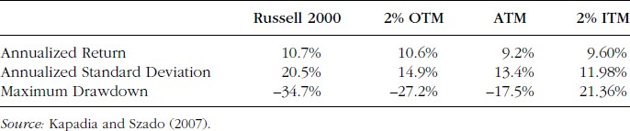Risk Management Using Options: Covered Call
Performance Statistics for Comparison Spot and Buy-Write: Summary Statistics for the One-Month to Expiration Russell 2000 Buy-Write (January 18, 1996−November 16, 2006)

  - The results of the study by Kapadia and Szado (2007) suggest that the buy-write strategy is capable of enhancing return and providing some loss mitigation if applied in the right market environment.
  - While the buy-write strategy is often referred to in the literature as a hedging or downside protection strategy, it would be more accurate to think of it as a return enhancing strategy.
    - The small returns typically generated month to month from the option volatility risk premium tend to
provide a cushion in market down moves and a return enhancement in sideways markets.

Investment Management Analyst Certificate (IMAC) | Portfolio Risk Management Strategies 53

Risk Management Using Options: Long Collar

  - One of the limiting factors of the use of the buy-write is that it it leaves one exposed to the full downside of the underlying’s return distribution.

  - The collar strategy can address this shortcoming.

  - A long collar strategy involves the purchase of a put against a long position in the underlying, combined with the writing of a call on the same underlying.
- The long collar essentially combines a buy-write strategy with a protective put.
- The purpose of the put is to provide protection against a downside move of the long underlying position.
- The call is written to at least partially cover the cost of the purchase of the put, at the expense of limiting the strategy’s participation in upside moves of the underlying.

  - A collar strategy is particularly appealing for investors who are seeking some protection from a
potential downside move, or a reduction in the market exposure of their portfolio.

Investment Management Analyst Certificate (IMAC) | Portfolio Risk Management Strategies 56

Long Collar
  - Relative to a long position in the underlying index, the collar strategy has the highest advantage when the market experiences a strong downward trend and has the highest relative disadvantage during sustained strong upward trends.
  - To take advantage of the faster time decay of short-term options, the collar can be implemented using six-month puts and one-month calls.
    - In this way, the long six-month put decays relatively slowly, while each sequential one-month short call
decays quickly.

  - Ultimately, the risk of the collar strategy relative to holding the underlying is an opportunity cost risk. This risk is common to any hedging program.
    - If the underlying performs extremely well, then a portion of the potential returns will be lost on the short call
position (which is written to fund the purchase of the put’s downside protection).

  - The ultimate relative benefit of the collar is equivalent to the protection provided by a standard insurance contract or hedge; that is, if the market experiences a significant downward move, losses are largely eliminated.

Investment Management Analyst Certificate (IMAC) | Portfolio Risk Management Strategies 58

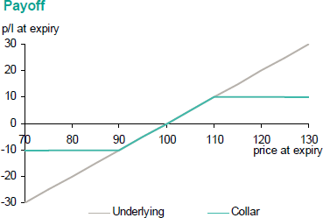Long Collar

Collar Strategy
- An investor holding a stock buys a put option on that stock and funds the purchase through selling an upside call option.
- More typically constructed at index level for portfolio protection.
- Usually constructed to minimise premium.

Investment Management Analyst Certificate (IMAC) | Portfolio Risk Management Strategies 59

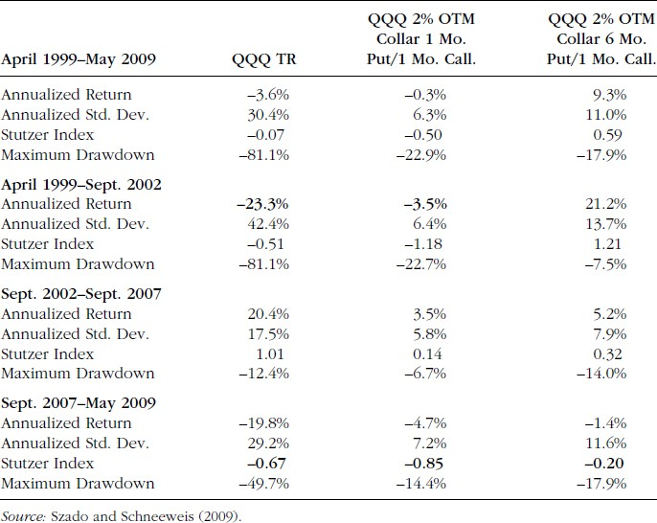Risk Management Using Options: Long Collar
Performance Statistics for Underlying and Long Collar April 1999−May 2009

QQQ :
NASDAQ ETF

Investment Management Analyst Certificate (IMAC) | Portfolio Risk Management Strategies 61

Value at Risk

Investment Management Analyst Certificate (IMAC) | Portfolio Risk Management Strategies 64

Value at Risk (VaR)

- Value-at-Risk quantifies the risk of loss on a portfolio over a specific investment horizon.

VaR is the maximum loss in portfolio value that is expected to occur in a specified time horizon with a given confidence level c.

- Alternatively, VaR is the minimum loss in portfolio value that is expected to occur in a specified time horizon with a given probability, p. (p = 1 – c)

  - Typically, value-at-risk looks at a 95% confidence level over 1 day horizon;

  - Value-at-risk can be reported either as a dollar amount or as a percentage of fund assets.

Investment Management Analyst Certificate (IMAC) | Portfolio Risk Management Strategies 65

What is VaR

- Fixing a confidence level c (e.g. 99%) and a time horizon (e.g. 2 weeks), the VaR of a given
portfolio is the loss in market value that is exceeded with probability 1-c.
  - i.e. if c = 0.99, then the loss exceeds the VaR with 1% probability.

- There is a probability of p% that the portfolio will suffer a loss greater than VaR during the planning period.

- Typically p is taken to be 1% or 5%

- Planning period is 1-day (for active trading), or 1-month (for portfolio management), or the 10-day holding period specified in the BIS directives.

Investment Management Analyst Certificate (IMAC) | Portfolio Risk Management Strategies 68

Value-at-Risk illustration

Daily Profit and Loss Distribution
Zero Change Line

Value-at-Risk
Probability

VaR Example
Profit and Loss (AUD)

- A portfolio manager reports that a portfolio has a one-day VaR of $30,000.
- This means that based on historical data and/or mathematical modeling, 95% of the time the portfolio did not
decline in value by more than $30,000.

Investment Management Analyst Certificate (IMAC) | Portfolio Risk Management Strategies 69

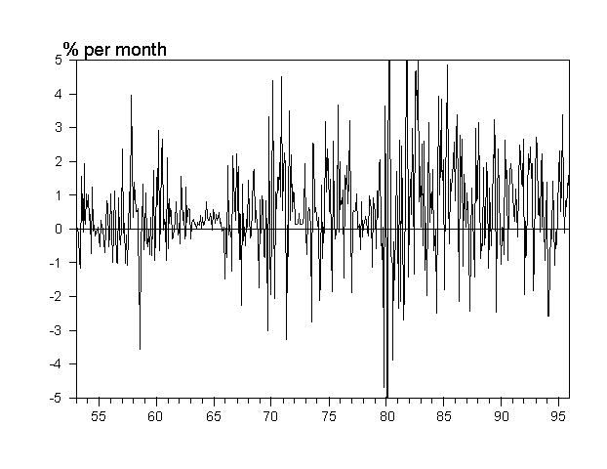VaR: Example

- Consider a $100 million portfolio of medium-term bonds. Assuming a confidence interval of 95% (i.e., 95% of possible market events is defined as “normal”.) Then, what is the maximum monthly loss under normal markets over any month?
- To answer this question, look at the monthly medium-term bond returns from 1953 to 1995:
- Lowest: -6.5% vs. Highest: 12%

Investment Management Analyst Certificate (IMAC) | Portfolio Risk Management Strategies 72

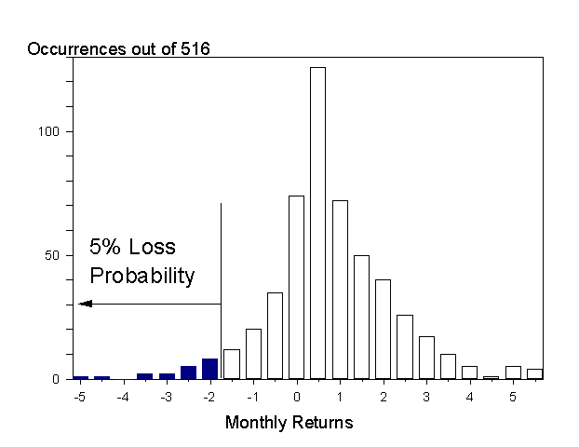Distribution of Medium Bond Returns

Investment Management Analyst Certificate (IMAC) | Portfolio Risk Management Strategies 74

VaR : Analytic Methods

- Assume the returns on risk factors are normally distributed, the VaR for an investment with a
mark-to-market value of W0

VaR p %,T = exposure×σ daily ×
VaR =Vt ×σ×α
T ×α

a: number of standard deviations corresponding to confidence level, c.
*********** Assuming zero mean return. ************

For a portfolio of instruments
VaR =αV σ2 =αV w'Ωw =α x 'Ωx
p t p t

Ω= variance-covariance matrix of returns
- Assumes portfolio exposures are linear in the underlying risk factors.

Investment Management Analyst Certificate (IMAC) | Portfolio Risk Management Strategies 75

Value–at-Risk: Unifying Approach

- Translates portfolio exposures into potential P&L

- Aggregates and reports multi-product, multi-market exposures into one number

- Based on statistics, VaR is valuable as a probabilistic measure of potential losses.

- Employs concepts from Portfolio Theory.

- May be subjected to verification and validation.

Widely accepted as a measure of market risk

- Easy comparison.

Investment Management Analyst Certificate (IMAC) | Portfolio Risk Management Strategies 78

Risk Budgeting & Risk Decomposition of the Portfolio with VaR

Asset allocation is the process of creating a portfolio with a proper risk-return balance.
- Risk budgeting is the process by which these efficient portfolio allocations are transformed
into VaR assignments.
- Risk budgeting is the process of parcelling out the total risk of the fund, or risk budget, to various assets classes and managers.

- Now consider using value at risk (VaR) to measure a portfolio’s overall risk.
- The VaR of a portfolio can be decomposed to determine how allocation to each asset class contributes to the total risk of the portfolio

- The VaR of a portfolio measures its potential losses due to market risks.
- The daily VaR of a portfolio at the confidence level of c states that the portfolio will not suffer a loss greater
than VaR with probability of c.

Risk budget is measured by each position’s VaR.

Investment Management Analyst Certificate (IMAC) | Portfolio Risk Management Strategies 80

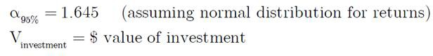Risk Budgeting: Useful formulae

Investment Management Analyst Certificate (IMAC) | Portfolio Risk Management Strategies 81

Risk Budgeting Using VaR: Example

Investment Management Analyst Certificate (IMAC) | Portfolio Risk Management Strategies 84

Risk Budgeting: Example

  - Consider an investor having to decide how much to invest in U.S. stocks, in U.S. bonds, and in non-U.S. bonds. (Amount to be invested = $100 million)

  - Risk is measured in absolute terms, assuming returns have a joint normal distribution. The allocation will depend on the expected return and volatility of each asset class, as well as their correlations.

  - The selected portfolio has an expected return of 12.0% with total risk of 10.3%. Table below shows a portfolio allocation of 60.0%, 7.7%, and 32.3% to U.S. stocks, U.S. bonds, and non-U.S. bonds, respectively.

  - The volatility can be measured in terms of a 95% annual VAR.
- This defines a total risk budget of VaR = 1.645 × 10.3% × $100 = -$16.9 million. This VaR budget can then be parcelled out to various asset classes and active managers within asset classes.

Investment Management Analyst Certificate (IMAC) | Portfolio Risk Management Strategies 85

Risk Budgeting: Example

- At the asset class level, the individual VaRs are $15.3, $0.9, and $5.9 million, respectively.
  - Example: the VaR budget for U.S. stocks is 60.0% × (1.645 × 15.50% × $100) = $15.3 million.

- Note that the sum of individual VARs is $22.1 million, which is greater than the portfolio VaR of
$16.9 million due to diversification effects.

Correlations
Asset |  | Expected Return | Volatility | 1 | 2 | 3 | Percentage Allocation | VaR
U.S. stocks | 1 | 13.80% | 15.50% | 1.00 |  |  | 60.0 | $15.3
U.S. bonds | 2 | 8.40% | 7.40% | 0.20 | 1.00 |  | 7.7 | $0.9
Non-U.S. bonds | 3 | 9.60% | 11.10% | 0.04 | 0.40 | 1.00 | 32.3 | $5.9
Portfolio |  | 12.00% | 10.30% |  |  |  | 100.0 | $16.9

Investment Management Analyst Certificate (IMAC) | Portfolio Risk Management Strategies 87

Risk Budgeting: Example
  - The process can be repeated at the next level.
  - The fund has a risk budget of $15.3 million devoted to U.S. equities, with an allocation of $60 million. This allocation could be split equally between two active equity managers.
- Assume that the two managers are equally good, with a correlation of returns of 0.5. The optimal risk budget
for each is then $8.83 million. We can verify that the total risk budget is

  - Note that, as in the previous step, the sum of the risk budgets, which is $8.83 + $8.83 = $17.66 million, is greater than the total risk budget of $15.3 million. This is because the latter takes into account diversification effects.
  - If the two managers were perfectly correlated with each other, the risk budget would have to be
$15.3/2 = $7.65 million for each. This higher risk budget is beneficial for the investor because it
creates more opportunities to take advantage of the managers’ positive alphas.

Investment Management Analyst Certificate (IMAC) | Portfolio Risk Management Strategies 90

Risk Budgeting
- The risk budgeting process highlights the importance of correlations across managers.
  - To control their risk better, institutional investors often choose equity managers that follow different market
segments or strategies.
  - For example, the first manager could invest in small growth stocks, the second in medium-size value stocks. Or the first manager could follow momentum-based strategies, the second value-based strategies. The first type tends to buy more of a stock after its price has gone up, and the second after the price has become more attractive (i.e., low).

- Different styles lead to low correlations across managers. For a given total risk budget, low correlations mean that each manager can be assigned a higher risk budget, leading to a greater value added for the fund.
  - These low correlations explain why investors must watch for style drift, which refers to a situation where an investment manager changes investment style. This is a problem for the investor because it can change the total portfolio risk. If all the managers, for instance, drift into the small growth stocks category, the total risk of the fund will increase.

Investment Management Analyst Certificate (IMAC) | Portfolio Risk Management Strategies 92

Risk Budgeting

- In conclusion, this risk budgeting approach is spreading rapidly to the field of investment
management. This approach provides a consistent measure of risk across all subportfolios.

- It forces managers and investors to confront squarely the amount of risk they are willing to
assume. It gives them tools to monitor their risk in real time.

Investment Management Analyst Certificate (IMAC) | Portfolio Risk Management Strategies 93

Marginal Risk and Contribution to Risk

- A well-designed risk system should also provide tools to understand how to manage risk. A risk report should display measures of marginal risk.

- Marginal Risk: represents the change in risk due to a small increase in one of the allocations. Using the volatility of returns as the risk measure, this is the change in risk due to a small increase in one of the allocations.

- Using the volatility of returns as the risk measure, this is

  - Beta represents the marginal contribution of asset i to the risk of the total portfolio P.
  - A large value for β indicates that a small addition to this position will have a relatively large effect on the
portfolio risk.
  - Conversely, positions with large betas should be cut first because they will lead to the greatest reduction in
Invesrtmiseknt.Management Analyst Certificate (IMAC) | Portfolio Risk Management Strategies 95

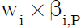Marginal Risk and Contribution to Risk

- Marginal VaR is a similar measure, except that MRISK is multiplied by the α that corresponds to
the confidence level.

- This can be expanded to measure contributions to the portfolio risk. The risk contribution, or
risk allocation, is obtained by multiplying the marginal risk for position i by its weight wi

- Because the beta of a portfolio with itself is one, the sum of is guaranteed to be one.

Hence, the sum of the risk contributions adds up exactly to the total portfolio risk, P .

Investment Management Analyst Certificate (IMAC) | Portfolio Risk Management Strategies 97

Marginal Risk and Contribution to Risk

Asset | Volatility | Market Allocation | Marginal Risk | Risk Allocation
U.S. stocks | 15.50% | 60.0% | 0.1438 | 8.63%
U.S. bonds | 7.40% | 7.7% | 0.0278 | 0.21%
Non-U.S.  bonds | 11.10% | 32.3% | 0.0451 | 1.46%
Portfolio | 10.30% | 100.0% |  | 10.30%
Table above provides detailed analysis of portfolio risk.
  - The marginal risk column shows that U.S. stocks are the asset class with the greatest marginal contribution to the risk of the portfolio.
    - As an example, increasing the allocation from 60% to 61% increases the portfolio risk from 10.30% to 10.44%, which is an increase of 0.14%. This is precisely the marginal risk number of 0.14 multiplied by the 1% weight increase.
  - The last column shows the risk contribution, or allocation.
    - Out of a total portfolio risk of 10.30%, 8.63% is attributed to U.S. stocks. This high number reflects the high
volatility of this asset class, its high weight in the portfolio, as well as correlations.
Investment Management Analyst Certificate (IMAC) | Portfolio Risk Management Strategies 99

Marginal Risk and Contribution to Risk

- Such analysis provides useful insights into the structure of the portfolio. Given a scarce risk budget, high risk allocations can be justified only by expected returns that are high relative to other assets.

Investment Management Analyst Certificate (IMAC) | Portfolio Risk Management Strategies 101

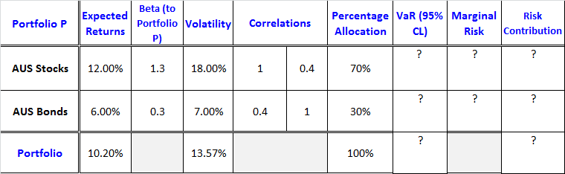Exercise: Risk Decomposition

  - Determine the risk budget using VaR for each position in Portfolio P?
  - Determine the VaR for the entire portfolio?
  - What is each position’s marginal risk? Explain how the marginal risk results can be used to manage the portfolio’s risk?
  - Determine the risk contribution of each position in the portfolio? Interpret your results.

Investment Management Analyst Certificate (IMAC) | Portfolio Risk Management Strategies 103

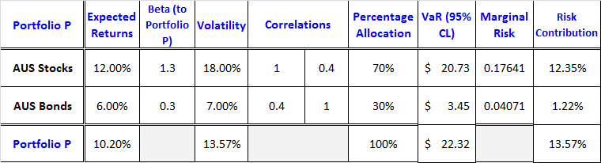Risk Decomposition Exercise: (Solution)

Investment Management Analyst Certificate (IMAC) | Portfolio Risk Management Strategies 105

Summary
- Application of risk management tools in the context of portfolio management does not mean elimination of risks. It means that the portfolio has the right balance of risk and return from the viewpoint of the investor.

- Risk management requires that a portfolio’s exposures to various risks be measured and monitored over time.

- Only those risks that contribute to the performance of the portfolio should be assumed and the others
should be eliminated, assuming the cost of doing so is close to zero.

- Decomposition of total risk as measured by VaR enables the portfolio manager to understand the contribution of each asset class to the total risk of a portfolio.

- Risk contribution of an asset class should be closely related to the contribution of that asset class to the
performance of the portfolio.
- Futures and options provide direct means both to reduce or enhance an asset’s standard deviation (futures) or to fundamentally change the characteristics of the distribution (options).

Investment Management Analyst Certificate (IMAC) | Portfolio Risk Management Strategies 108

APPENDIX

Investment Management Analyst Certificate (IMAC) | Portfolio Risk Management Strategies 109

Risk Management Using Futures

  - Futures markets provide a means of tracking underlying investment markets as well as providing
risk reduction opportunities.

  - Futures markets individuals to buy or sell financial assets for future delivery at a price set today, futures contracts offer a means to hedge the risk of unexpected price changes

  - A commodity, foreign currency, equity, or fixed income hedge is usually caused by buying (selling) a futures contract to initiate a futures position and closing out (offsetting) the position at a later date by selling (buying) the contract in the futures market rather than taking delivery.

  - The hedger benefits to the extent that a gain in the futures position offsets a loss in the spot
position.
- An investor purchasing long-term bonds in September may wish to reduce the risk of interest rate variability by simultaneously selling a December T-Bond futures contract. If interest rates rise during the holding period, the losses in the spot market are reduced by gains in the futures market.
Investment Management Analyst Certificate (IMAC) | Portfolio Risk Management Strategies 111

Risk Management Using Futures

  - Since price changes of the cash security and futures contract are often not of the same magnitude,
the success of the hedging strategy depends on determining the proper hedge ratio.

  - For many, the proper hedge ratio is determined simply by the relative sensitivity of the return on the spot asset to the return on the futures contract (e.g., beta for stocks, duration for bonds).

  - The actual number of contracts held is determined by the proper hedge ratio times the relative cash value of the spot position times the relative value of the futures contract.

Investment Management Analyst Certificate (IMAC) | Portfolio Risk Management Strategies 113

Risk Management Using Futures

- For equities, the minimum risk hedge ratio (Xf*) is equivalent to the negative of the slope
coefficient of regression of cash price changes on futures contract price changes.

- The higher the correlation between cash and futures price changes, the higher the expected effectiveness of the futures market for hedging purposes.

- The implementation of this model requires the use of regression of time series data of historical price changes of the cash instrument to be hedged (ΔPc) against the price changes of the futures contract (ΔPf).

The optimal hedge ratio (HR) is simply the slope coefficient of:

Investment Management Analyst Certificate (IMAC) | Portfolio Risk Management Strategies 116

Risk Management Using Futures

Example:

  - If an individual holds a $1 million position in a stock index, for an HR = 0.90, a $900,000 principal position (0.9 × $1 million) would be taken in the stock index futures market.

  - For stock index futures, the contract value depends on the level of the index.
- For example, if the S&P futures price is 1,006.90, the face value of the futures contract is
$251,725 (1,006.90 × $250). This would translate into four S&P futures contracts (e.g., $1 million ÷ $251,725 × 0.9 = 4).

  - The regression of the cash security and price changes in the futures contract are stable.

Investment Management Analyst Certificate (IMAC) | Portfolio Risk Management Strategies 117

Hedge Ratio Computation

- The futures hedge ratio is:
Example:

HR =

Dollar value of portfolio ×
Dollar value of S&P contract

Beta

You are managing a $90 million portfolio with a beta of 1.50. The portfolio is well-diversified and you want to short S&P 500 futures to hedge the portfolio. S&P 500 futures are currently trading for 353.00.
How many S&P 500 stock index futures should you short to hedge the portfolio?

HR =
Dollar value of
portfolio
- Beta

Dollar value of S& P contract
= $90,000,000 ×1.50
$250× 353
= 1,529.75
Solution: The hedge ratio indicates that you need 1,530 S&P 500 stock index futures contracts to hedge the
portfolio.
Investment Management Analyst Certificate (IMAC) | Portfolio Risk Management Strategies 119

Example

Consider the previous example. Assume that the S&P 500 index is currently at a level of 348.76.
Over the next few months, the S&P 500 index falls to 325.00.

Show the gains and losses for the stock portfolio and the S&P 500 futures, assuming you close out your futures position when the S&P 500 index is at 325.00.

Solution: For the $90 million stock portfolio:
–6.81% × 1.50 × $90,000,000 = $9,193,500 loss

For the futures:

(353 – 325) × 1,530 × $250 = $10,710,000 gain

Note: Hedge is not perfect!

Investment Management Analyst Certificate (IMAC) | Portfolio Risk Management Strategies 121

